PIG REPORT-Laxman Chamlagai

I’m the web designer in the project and will be working on developing the company’s website. Following are the tasks assigned to me:

* Create visual outline for AmazonDashboard application.
* Design and create a company logo.
* Develop UI of the website.

**Progress:**

WireFrame:

The visual outline for the application is completed. An example is the attached wireframe. Application will be developed using HTML5, CSS, Bootstrap,JQuery, JavaScript languages and its libraries. It will be designed to be a fully responsive application.

Tools needed for development work is fully installed and functional. I also started looking into some front end application templates to kick start the development work.

**Issues:**

One of the issues I have right now is converting the company logo to a oval shape using PS. Team thought is to use an oval shaped logo but will also accept if the logo is not oval and is a rectangular.

**Goals:**

To complete at least one actual front end page by end of next week.

My goals is to have the at least actual front end one page is developed by the end of the next week so the developers start to feel the application to map their code into the application.

MEDIABazaar Home Feature Partner Pricing Testimonial User Account

Logo |

Search

**Background & company name**

About Business

FB

Trade Mark & Copy Right Amazon-Dashboard @ 2021

Twitterr

YT

Log on

Some paragraph about business so customer can trust to use our site

Sales Report

Product

Team Testimonial:

Bio about team members with their photo.

Feature

Customer Review:

Some paragraph about customer review. Feed back on services and on the products they purchased

Through website.

Footer

Some Paragraph…………………………………………………………………………………………………………..

Link-Home

**Logo:**

Link-feature

Social Networking sites

Link-About

Trade Mark & Copy Right @ MediaBazaar 2021

**Initial look:**

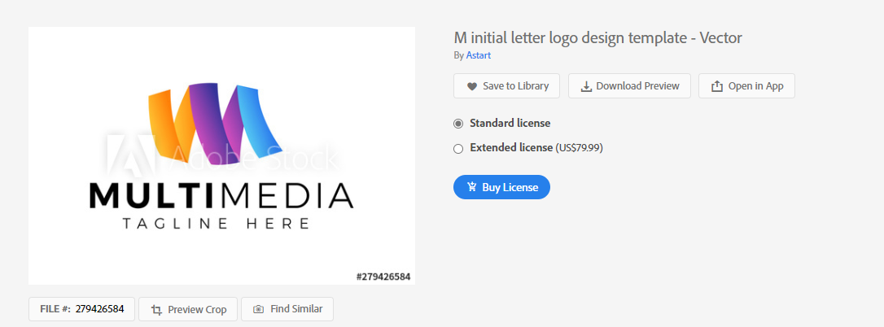

**Final Look:**

